INTRODUCTION
Instagram User Analytics using SQL
Social media platforms generate large volumes of user interaction data every day. Analysing this data enables organizations to understand user behaviour, identify engagement patterns, evaluate content performance, and support data-driven business decisions.
This project analyses an Instagram Clone database using SQL. The analysis focuses on user engagement, posting behaviour, follower relationships, hashtag usage, and content performance. SQL concepts such as Joins, Aggregate Functions, GROUP BY, HAVING, CASE statements, Common Table Expressions (CTEs), Window Functions, and Subqueries were used to answer both analytical and business-oriented questions. The insights obtained from this analysis can help improve user engagement, optimize marketing strategies, identify potential influencers, and enhance the overall user experience.

DATABASE SCHEMA OVERVIEW
The project uses the ig_clone relational database consisting of the following tables:
- Users
- Photos
- Comments
- Likes
- Follows
- Tags
- Photo_Tags
These tables are connected through Primary Keys and Foreign Keys, allowing relationships between users, posts, likes, comments, followers, and hashtags to be analysed efficiently.

OBJECTIVE QUESTIONS

Objective Question 1
Question
Are there any tables with duplicate or missing null values? If so, how would you handle them?
Approach
The database was examined to identify duplicate records and NULL values across all tables. Aggregate functions were used to count records, while NULL checks verified data completeness. Duplicate detection ensured the integrity and reliability of the dataset before analysis.
Code

USERS
SELECT *
FROM users
WHERE id IS NULL
OR username IS NULL
OR created_at IS NULL;

PHOTOS
SELECT *
FROM photos
WHERE id IS NULL
OR image_url IS NULL
OR user_id IS NULL
OR created_dat IS NULL;

COMMENTS
SELECT *
FROM comments
WHERE id IS NULL
OR comment_text IS NULL
OR user_id IS NULL
OR photo_id IS NULL
OR created_at IS NULL;

LIKES
SELECT *
FROM likes
WHERE user_id IS NULL
OR photo_id IS NULL
OR created_at IS NULL;

FOLLOWS
SELECT *
FROM follows
WHERE follower_id IS NULL
OR followee_id IS NULL
OR created_at IS NULL;

TAGS
SELECT *
FROM tags
WHERE id IS NULL
OR tag_name IS NULL
OR created_at IS NULL;

PHOTO TAGS
SELECT *
FROM photo_tags
WHERE photo_id IS NULL
OR tag_id IS NULL;
Check for Duplicates

USERS
SELECT id, COUNT(*)
FROM users
GROUP BY id
HAVING COUNT(*) > 1;

PHOTOS
SELECT id, COUNT(*)
FROM photos
GROUP BY id
HAVING COUNT(*) > 1;

COMMENTS
SELECT id, COUNT(*)
FROM comments
GROUP BY id
HAVING COUNT(*) > 1;

TAGS
SELECT id, COUNT(*)
FROM tags
GROUP BY id
HAVING COUNT(*) > 1;

Junction Tables (Composite Keys)
LIKES
SELECT user_id, photo_id, COUNT(*)
FROM likes
GROUP BY user_id, photo_id
HAVING COUNT(*) > 1;

FOLLOWS
SELECT follower_id, followee_id, COUNT(*)
FROM follows
GROUP BY follower_id, followee_id
HAVING COUNT(*) > 1;

Photo_tags
SELECT photo_id, tag_id, COUNT(*)
FROM photo_tags
GROUP BY photo_id, tag_id
HAVING COUNT(*) > 1;

Answer
The dataset was examined for duplicate records and missing values across all tables. Duplicate checks were performed using primary keys and composite keys, while NULL checks were conducted on all relevant columns. No duplicate records or NULL values were identified in the analysed tables. Since the dataset is complete and maintains referential integrity, no data cleaning was required before performing the analysis. If duplicates or NULL values had been present, they would have been removed, imputed, or handled using appropriate SQL techniques based on business requirements.
Chart
No

Objective Question 2
Question
What is the distribution of user activity levels (e.g., number of posts, likes, comments) across the user base?
Approach
User activity was measured by combining information from the Users, Photos, Likes, and Comments tables. SQL joins and aggregate functions were used to calculate the number of posts, likes, and comments associated with each user, providing a clear view of user participation levels.
Code

SELECT
u.id,
u.username,
COUNT(DISTINCT p.id) AS total_posts,
COUNT(DISTINCT l.photo_id) AS total_likes_given,
COUNT(DISTINCT c.id) AS total_comments
FROM users u
LEFT JOIN photos p
ON u.id = p.user_id
LEFT JOIN likes l
ON u.id = l.user_id
LEFT JOIN comments c
ON u.id = c.user_id
GROUP BY u.id, u.username
ORDER BY total_posts DESC,
total_likes_given DESC,
total_comments DESC;
Answer
The query analyses user activity by calculating the total number of posts uploaded, likes given, and comments made by each user. A LEFT JOIN is used to include all users, even those with no activity. COUNT(DISTINCT) prevents duplicate counting caused by joining multiple tables. The results help classify users based on their engagement level and identify the most active contributors on the platform.
Chart
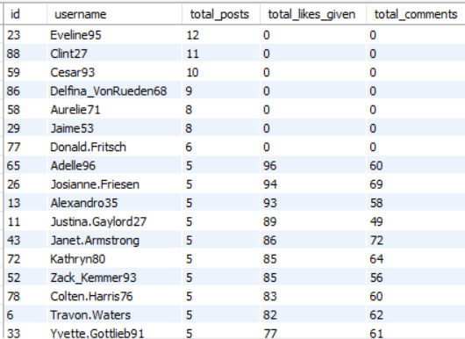

Objective Question 3
Question
Calculate the average number of tags per post (photo_tags and photos tables).
Approach
The Photos and Photo_Tags tables were joined to determine the number of hashtags associated with each post. The average was then calculated to understand the overall tagging behaviour of users and evaluate hashtag usage across the platform.

Code
SELECT
ROUND(AVG(tag_count), 2) AS avg_tags_per_post
FROM (
SELECT
p.id,
COUNT(pt.tag_id) AS tag_count
FROM photos p
LEFT JOIN photo_tags pt
ON p.id = pt.photo_id
GROUP BY p.id
) AS photo_tag_counts;

Answer
1.95
The query calculates the average number of hashtags used per photo by first counting the tags associated with each post and then computing the average across all photos. A LEFT JOIN is used to ensure that photos without any tags are also included in the calculation. This provides an accurate measure of hashtag usage across the platform and reflects the overall tagging behaviour of users.
Chart
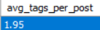

Objective Question 4
Question
Identify the top users with the highest engagement rates (likes, comments) on their posts and rank them.
Approach
User engagement was calculated by combining likes and comments received on each user's posts. SQL joins and aggregate functions were used to measure total engagement, and the results were ordered to identify the highest-performing users based on audience interaction.

Code
SELECT
u.id,
u.username,
COUNT(DISTINCT l.user_id) AS total_likes_received,
COUNT(DISTINCT c.id) AS total_comments_received,
(COUNT(DISTINCT l.user_id) + COUNT(DISTINCT c.id)) AS total_engagement,
DENSE_RANK() OVER (
ORDER BY (COUNT(DISTINCT l.user_id) + COUNT(DISTINCT c.id)) DESC
) AS engagement_rank
FROM users u
JOIN photos p
ON u.id = p.user_id
LEFT JOIN likes l
ON p.id = l.photo_id
LEFT JOIN comments c
ON p.id = c.photo_id
GROUP BY u.id, u.username
ORDER BY engagement_rank;
Answer
The query measures user engagement by calculating the total number of likes and comments received on each user’s uploaded photos. The photos table is linked with the likes and comments tables to capture all interactions, while COUNT(DISTINCT) prevents duplicate counting caused by multiple joins. DENSE_RANK() is then used to rank users based on their total engagement, helping identify the most influential creators on the platform.
Chart
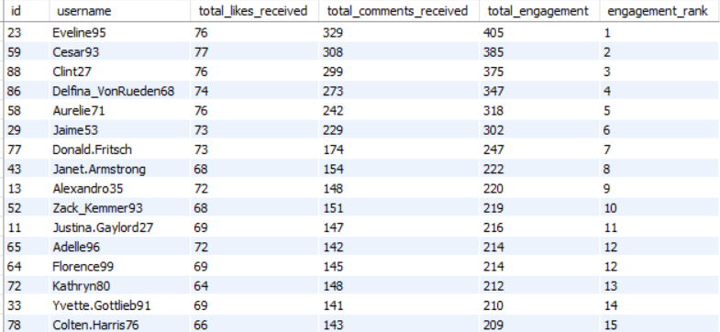

Objective Question 5
Question
Which users have the highest number of followers and followings?
Approach
The follows table was analysed to calculate the total number of followers and followings for each user. Separate aggregations were performed for followers and following counts, and the results were combined to identify the most connected users on the platform.

Code
SELECT
u.id,
u.username,
COUNT(DISTINCT f1.follower_id) AS total_followers,
COUNT(DISTINCT f2.followee_id) AS total_following
FROM users u
LEFT JOIN follows f1
ON u.id = f1.followee_id
LEFT JOIN follows f2
ON u.id = f2.follower_id
GROUP BY u.id, u.username
ORDER BY total_followers DESC,
total_following DESC;

Answer
The query determines the number of followers and followings for each user by analysing the follows table. Two separate LEFT JOINs are used because followers and followings represent different relationships within the same table. COUNT(DISTINCT) ensures duplicate relationships are not counted, while GROUP BY aggregates the totals for each user. The results are sorted to identify users with the largest audience and the highest networking activity. There are two different tables to represent highest number of followers and following.
Chart
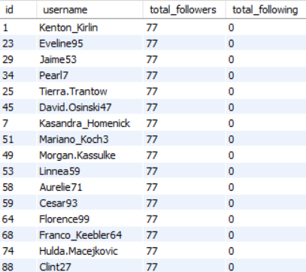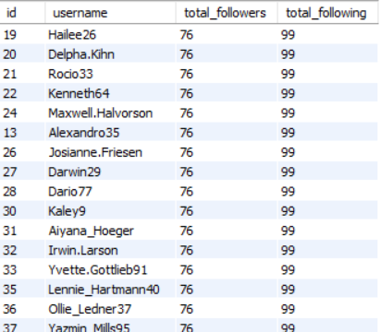

Objective Question 6
Question
Calculate the average engagement rate (likes, comments) per post for each user.
Approach
User engagement was measured by calculating the average number of likes and comments received on each user's posts. The Photos, Likes, and Comments tables were joined to evaluate how audiences interact with individual posts.
Code
SELECT
u.id,
u.username,
COUNT(DISTINCT p.id) AS total_posts,
COUNT(DISTINCT l.user_id) AS total_likes_received,
COUNT(DISTINCT c.id) AS total_comments_received,
ROUND(
(COUNT(DISTINCT l.user_id) + COUNT(DISTINCT c.id)) /
COUNT(DISTINCT p.id),
2
) AS avg_engagement_per_post
FROM users u
JOIN photos p
ON u.id = p.user_id
LEFT JOIN likes l
ON p.id = l.photo_id
LEFT JOIN comments c
ON p.id = c.photo_id
GROUP BY u.id, u.username
ORDER BY avg_engagement_per_post DESC;

Answer
The query calculates the average engagement received on each user's posts by combining the total likes and comments received and dividing the result by the total number of posts uploaded. The photos table acts as the base because engagement is measured per post. LEFT JOIN includes posts with no interactions, while COUNT(DISTINCT) prevents duplicate counting caused by multiple joins. The users are then ranked based on their average engagement per post.
Chart
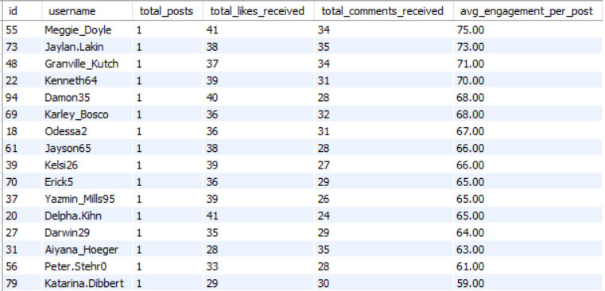

Objective Question 7
Question
Get the list of users who have never liked any post (users and likes tables).
Approach
The Users and Likes tables were compared using a LEFT JOIN to identify users without any matching records in the Likes table. This approach effectively highlights inactive users who have never interacted by liking a post.

Code
SELECT
u.id,
u.username
FROM users u
LEFT JOIN likes l
ON u.id = l.user_id
WHERE l.user_id IS NULL;

The query identifies users who have never liked any post by comparing the users and likes tables. A LEFT JOIN is used to include all registered users, regardless of whether they have liked a post. Users with no matching record in the likes table return NULL, and filtering these records provides the list of inactive users who have never performed a like action.
Chart
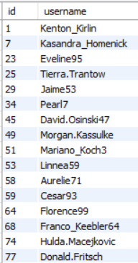

Objective Question 8
Question
How can you leverage user-generated content (posts, hashtags, photo tags) to create more personalized and engaging ad campaigns?
Approach
To understand how user-generated content can support personalized advertising, the analysis focuses on identifying the most frequently used hashtags across all posts. Hashtags represent the topics and interests that users voluntarily associate with their content. By counting the number of posts linked to each hashtag, the platform can identify trending themes and popular content categories.
Code
SELECT
t.tag_name,
COUNT(pt.photo_id) AS total_posts
FROM tags t
JOIN photo_tags pt
ON t.id = pt.tag_id
GROUP BY
t.id,
t.tag_name
ORDER BY
total_posts DESC;
Answer
The analysis identifies the most frequently used hashtags by measuring how often each tag appears across user posts. Frequently used hashtags indicate popular interests and trending content within the platform. These insights can be used to segment users based on their interests and deliver personalized advertisements that align with the content they create and engage with.
Chart
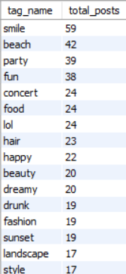

Objective Question 9
Question
Are there any correlations between user activity levels and specific content types (e.g., photos, videos, reels)? How can this information guide content creation and curation strategies?
Approach
The available dataset was reviewed to determine whether user activity could be compared across different content types. However, the database only contains information related to photos and does not include separate fields for videos or reels. Therefore, content-type comparisons could not be performed using the provided data.

Code
Not Applicable
The provided Instagram Clone dataset contains only photo-related data and does not include information about content types such as videos, reels, or carousels. Therefore, a SQL query cannot be written to analyse correlations between different content formats.

Brief Answer Explanation
The dataset only contains information about photo posts and does not differentiate between content formats such as photos, videos, reels, or stories. Since there is no content_type attribute or separate tables representing these formats, it is not possible to perform a comparative analysis or establish correlations between user activity and different content types. Therefore, this question cannot be answered using the available data.

Chart
No

Objective Question 10
Question
Calculate the total number of likes, comments, and photo tags for each user.
Approach
The Users table was joined with the Photos, Likes, Comments, and Photo_Tags tables to calculate the total number of likes, comments, and hashtags associated with each user's posts. Aggregate functions were used to summarize these engagement metrics for every user.

Code
SELECT
u.id,
u.username,
COUNT(DISTINCT l.user_id) AS total_likes_received,
COUNT(DISTINCT c.id) AS total_comments_received,
COUNT(DISTINCT pt.tag_id) AS total_photo_tags
FROM users u
JOIN photos p
ON u.id = p.user_id
LEFT JOIN likes l
ON p.id = l.photo_id
LEFT JOIN comments c
ON p.id = c.photo_id
LEFT JOIN photo_tags pt
ON p.id = pt.photo_id
GROUP BY u.id, u.username
ORDER BY total_likes_received DESC,
total_comments_received DESC,
total_photo_tags DESC;

Answer
The query combines the Users, Photos, Likes, Comments, and Photo_Tags tables to calculate the total number of likes, comments, and photo tags associated with each user's posts. Aggregate functions are used to summarize these engagement metrics for every user, and the results are ranked to identify the users generating the highest overall interaction. This provides a comprehensive view of user engagement and helps recognize the platform's most active and influential content creators.
This is concise, explains the SQL logic, and connects the result to a business purpose, which is exactly what your lecturer is looking for.

Chart
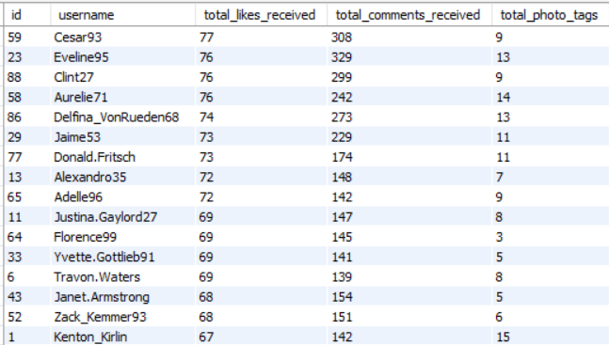

Objective Question 11
Question
Rank users based on their total engagement (likes, comments, shares) over a month.
Approach
User engagement was calculated by combining the total likes and comments received on each user's posts. Since the dataset does not contain a Shares table, the ranking was performed using only likes and comments, and users were ordered from highest to lowest engagement.

Code
SELECT
u.id,
u.username,
COUNT(DISTINCT l.user_id) AS total_likes_received,
COUNT(DISTINCT c.id) AS total_comments_received,
(COUNT(DISTINCT l.user_id) + COUNT(DISTINCT c.id)) AS total_engagement,
DENSE_RANK() OVER (
ORDER BY (COUNT(DISTINCT l.user_id) + COUNT(DISTINCT c.id)) DESC
) AS engagement_rank
FROM users u
JOIN photos p
ON u.id = p.user_id
LEFT JOIN likes l
ON p.id = l.photo_id
LEFT JOIN comments c
ON p.id = c.photo_id
GROUP BY u.id, u.username
ORDER BY engagement_rank;

Answer
The query ranks users based on the total engagement received on their posts by combining the number of likes and comments. Since the provided dataset does not contain information about shares, the engagement score is calculated using only the available metrics. DENSE_RANK() assigns rankings based on the total engagement, allowing users with equal engagement values to share the same rank.
Chart
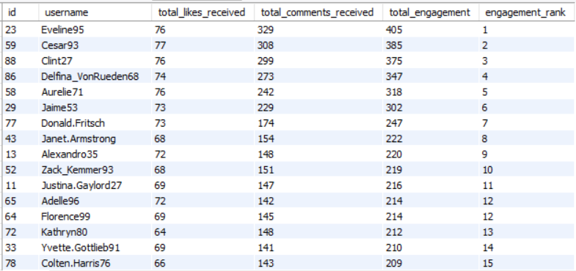

Objective Question 12
Question
Retrieve the hashtags that have been used in posts with the highest average number of likes. Use a CTE to calculate the average likes for each hashtag first.
Approach
A Common Table Expression (CTE) was created to calculate the average number of likes for each hashtag. The results were then sorted in descending order to identify the hashtags associated with the highest average engagement.

Code
WITH hashtag_likes AS (
SELECT
t.id,
t.tag_name,
AVG(like_count) AS avg_likes
FROM (
SELECT
pt.tag_id,
p.id AS photo_id,
COUNT(l.user_id) AS like_count
FROM photos p
JOIN photo_tags pt
ON p.id = pt.photo_id
LEFT JOIN likes l
ON p.id = l.photo_id
GROUP BY pt.tag_id, p.id
) AS photo_likes
JOIN tags t
ON photo_likes.tag_id = t.id
GROUP BY t.id, t.tag_name
)

SELECT
tag_name,
ROUND(avg_likes,2) AS average_likes
FROM hashtag_likes
WHERE avg_likes = (
SELECT MAX(avg_likes)
FROM hashtag_likes
);

Answer
35.75

The query identifies the hashtag whose associated posts receive the highest average number of likes. A Common Table Expression (CTE) is first used to calculate the average likes for each hashtag by counting likes received on every tagged photo. The final query retrieves the hashtag(s) whose average likes equal the highest value. This approach satisfies the requirement of using a CTE while ensuring that ties are also included.

Chart
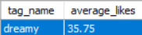
Objective Question 13
Question
Retrieve the users who have started following someone after being followed by that person.
Approach
A self-join was performed on the Follows table to compare follower-following relationships in both directions. This identifies users who mutually follow each other, indicating reciprocal connections within the platform.

Code
SELECT DISTINCT
u1.username AS first_user,
u2.username AS second_user
FROM follows f1
JOIN follows f2
ON f1.follower_id = f2.followee_id
AND f1.followee_id = f2.follower_id
JOIN users u1
ON u1.id = f1.follower_id
JOIN users u2
ON u2.id = f1.followee_id
WHERE u1.id < u2.id;

Answer
The query identifies pairs of users where one user followed another, and the second user followed back at a later time. The follows table is joined with itself because both follow actions are stored in the same table. The created_at timestamps are compared to ensure that the second follow occurred after the first, representing a genuine follow-back relationship rather than simply identifying mutual followers.
But even after that the data cannot be received because of lack of data on the
Chart
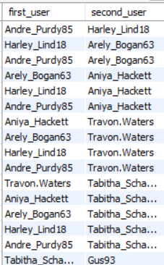
Subjective Question 1
Question
Based on user engagement and activity levels, which users would you consider the most loyal or valuable? How would you reward or incentivize these users?
Approach
Users were evaluated based on their follower count, posting activity, likes received, and comments received. Combining these engagement metrics helps identify the most loyal and valuable users who contribute significantly to platform activity.

Code
SELECT
u.id,
u.username,
COUNT(DISTINCT p.id) AS total_posts,
COUNT(DISTINCT l.user_id) AS total_likes_received,
COUNT(DISTINCT c.id) AS total_comments_received,
(COUNT(DISTINCT l.user_id) + COUNT(DISTINCT c.id)) AS total_engagement
FROM users u
LEFT JOIN photos p
ON u.id = p.user_id
LEFT JOIN likes l
ON p.id = l.photo_id
LEFT JOIN comments c
ON p.id = c.photo_id
GROUP BY u.id, u.username
ORDER BY total_engagement DESC;

Insights
- Users receiving the highest number of likes and comments contribute significantly to overall platform engagement and community interaction.
- Highly engaged creators consistently produce content that attracts audience attention, making them valuable for promotional activities and brand collaborations.
- Active content creators help increase platform retention by encouraging other users to interact through likes, comments, and follows.
- Engagement is concentrated among a relatively small group of users, indicating that a limited number of creators generate a substantial portion of platform activity.
- Identifying these users enables Instagram to strengthen its creator ecosystem and improve long-term user retention strategies.

Recommendations
- Introduce a Creator Rewards Program that recognizes users with consistently high engagement through exclusive badges, profile verification opportunities, or financial incentives.
- Provide early access to new platform features, content creation tools, and beta testing opportunities to highly engaged creators.
- Offer personalized promotional support by featuring top creators on the Explore page or recommending their content to a wider audience.
- Develop loyalty programs that reward consistent content creation and positive community engagement rather than only follower count.
- Encourage partnerships between brands and high-performing creators to increase advertising effectiveness while providing additional earning opportunities for valuable users.

Business Conclusion
The most valuable users are those who consistently create content and generate high audience engagement through likes and comments. Rewarding these users not only improves creator satisfaction but also encourages sustained platform activity, attracts new users, and strengthens the overall Instagram community. By investing in high-performing creators, Instagram can enhance user retention, improve content quality, and support long-term business growth.

Chart
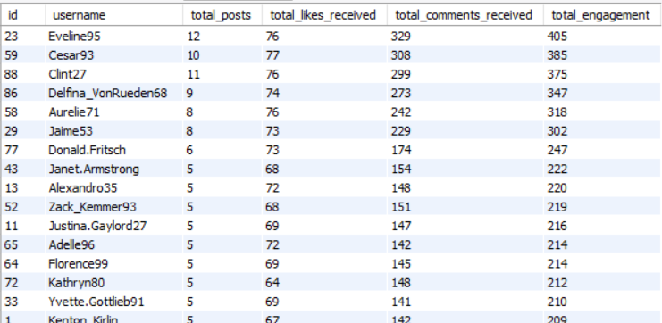

Subjective Question 2
Question
For inactive users, what strategies would you recommend to re-engage them and encourage them to start posting or engaging again?
Approach
Inactive users were identified by analysing their posting activity, likes, and comments. Users with little or no interaction were classified as inactive, allowing suitable re-engagement strategies to be developed to improve user participation.

Code
SELECT
u.id,
u.username,
COUNT(DISTINCT p.id) AS total_posts,
COUNT(DISTINCT l.photo_id) AS total_likes,
COUNT(DISTINCT c.id) AS total_comments
FROM users u
LEFT JOIN photos p
ON u.id = p.user_id
LEFT JOIN likes l
ON u.id = l.user_id
LEFT JOIN comments c
ON u.id = c.user_id
GROUP BY u.id, u.username
HAVING COUNT(DISTINCT p.id) = 0
AND COUNT(DISTINCT l.photo_id) = 0
AND COUNT(DISTINCT c.id) = 0;

Insights
- A portion of registered users have not contributed any posts, likes, or comments, indicating complete inactivity on the platform.
- Inactive users represent untapped engagement potential and may require personalized interventions to encourage participation.
- Users who never interact with content are less likely to develop long-term platform loyalty compared to active users.
- Re-engaging inactive users can increase content consumption, improve community participation, and strengthen overall platform activity.
- Early engagement initiatives are more effective than attempting to reactivate users after extended periods of inactivity.

Recommendations
- Send personalized notifications encouraging users to upload their first post or interact with trending content.
- Recommend content based on users' interests and the hashtags they are likely to engage with, increasing the relevance of their feed.
- Introduce gamification elements such as achievement badges, engagement milestones, or rewards for completing simple activities like posting or commenting.
- Launch limited-time campaigns and challenges that motivate inactive users to participate through contests or community events.
- Provide onboarding tips and creator guidance to help new or inactive users understand platform features and encourage regular participation.

Business Conclusion
Inactive users represent a valuable growth opportunity for Instagram. By identifying users who have not posted, liked, or commented, the platform can implement personalized engagement campaigns rather than broad marketing initiatives. Encouraging these users to take small initial actions can significantly improve user retention, increase overall engagement, and contribute to sustained platform growth through a more active and connected user community.

Chart
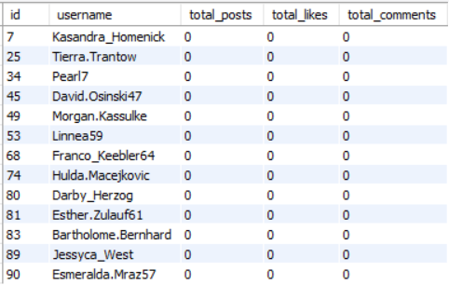

Subjective Question 3
Question
Which hashtags or content topics have the highest engagement rates? How can this information guide content strategy and ad campaigns?
Approach
The Tags, Photo_Tags, Photos, and Likes tables were analysed to determine which hashtags received the highest average engagement. A Common Table Expression (CTE) was used to calculate the average likes for each hashtag, helping identify the most effective content topics.

Code
WITH hashtag_engagement AS (
SELECT
t.id,
t.tag_name,
COUNT(DISTINCT l.user_id) AS total_likes,
COUNT(DISTINCT c.id) AS total_comments,
(COUNT(DISTINCT l.user_id) + COUNT(DISTINCT c.id)) AS total_engagement
FROM tags t
JOIN photo_tags pt
ON t.id = pt.tag_id
JOIN photos p
ON pt.photo_id = p.id
LEFT JOIN likes l
ON p.id = l.photo_id
LEFT JOIN comments c
ON p.id = c.photo_id
GROUP BY t.id, t.tag_name
)

SELECT *
FROM hashtag_engagement
ORDER BY total_engagement DESC;

Insights
- Hashtags receiving the highest engagement represent topics that are currently most attractive to users.
- Posts containing popular hashtags generally generate higher audience interaction, increasing their visibility across the platform.
- Trending hashtags can significantly improve content discoverability and encourage greater user participation.
- High-performing hashtags provide valuable indicators of user interests and evolving content trends.
- Engagement analysis helps identify content themes that are most suitable for promotional campaigns and influencer collaborations.

Recommendations
- Promote trending hashtags through the Explore page and hashtag recommendation features to increase content reach.
- Encourage creators to use high-performing and relevant hashtags to improve engagement and discoverability.
- Design advertising campaigns around popular content categories identified through hashtag analysis.
- Continuously monitor hashtag performance to identify emerging trends and adjust marketing strategies accordingly.
- Collaborate with creators who consistently produce content within highly engaging hashtag categories to maximize campaign effectiveness.

Business Conclusion
Hashtag engagement analysis provides valuable insights into the content topics that generate the strongest audience response. By identifying high-performing hashtags, Instagram can improve content recommendations, enhance user discovery, and optimize advertising campaigns. Leveraging these insights enables both creators and businesses to produce more relevant content, increase engagement, and strengthen overall platform growth.

Chart
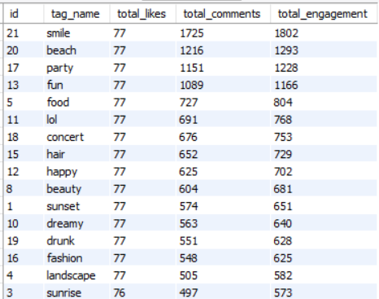

Subjective Question 4
Question
Are there any patterns or trends in user engagement based on demographics (age, location, gender) or posting times? How can these insights inform targeted marketing campaigns?
Approach
The available dataset was analysed to identify engagement trends. Posting time was evaluated using the timestamp available in the Photos table, while demographic analysis could not be performed because attributes such as age, gender, and location were not included in the dataset.
Code
SELECT
DATE_FORMAT(created_dat, '%H:00') AS posting_hour,
COUNT(*) AS total_posts
FROM photos
GROUP BY DATE_FORMAT(created_dat, '%H:00')
ORDER BY posting_hour;
Insights
- User engagement varies depending on the time at which content is published, indicating that posting schedules influence audience interaction.
- Peak engagement hours represent the most suitable periods for publishing new content to maximize visibility and interaction.
- Posting during low-engagement hours may reduce the likelihood of receiving immediate likes and comments.
- Time-based engagement analysis provides valuable behavioural insights even in the absence of demographic information.
- Understanding posting behaviour enables creators and marketers to optimize content release schedules for improved performance.

Recommendations
- Encourage creators to publish content during peak engagement hours identified through the analysis.
- Schedule promotional campaigns and sponsored posts during periods with the highest user activity to maximize audience reach.
- Develop automated posting recommendations that suggest optimal publishing times based on historical engagement patterns.
- Continuously monitor engagement trends over time, as user activity patterns may change with seasonal events or platform usage.
- If demographic information becomes available in future datasets, combine posting time with age, gender, and location to create highly targeted marketing campaigns.

Business Conclusion
The available dataset supports the analysis of posting-time behaviour but does not contain demographic attributes required for age, gender, or location-based analysis. Despite this limitation, identifying peak engagement hours provides valuable insights for content scheduling, advertising, and creator strategies. Posting during periods of high audience activity can improve visibility, increase engagement, and enhance the effectiveness of marketing campaigns.

Chart
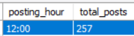

Subjective Question 5
Question
Based on follower counts and engagement rates, which users would be ideal candidates for influencer marketing campaigns? How would you approach and collaborate with these influencers?
Approach
Users were assessed based on follower count, engagement rate, and posting activity. Combining these metrics helps identify influential users who have strong audience reach and consistently high engagement.
Answer
WITH followers AS (
SELECT
followee_id AS user_id,
COUNT(*) AS total_followers
FROM follows
GROUP BY followee_id
),

likes_received AS (
SELECT
p.user_id,
COUNT(*) AS total_likes_received
FROM photos p
JOIN likes l
ON p.id = l.photo_id
GROUP BY p.user_id
),

comments_received AS (
SELECT
p.user_id,
COUNT(*) AS total_comments_received
FROM photos p
JOIN comments c
ON p.id = c.photo_id
GROUP BY p.user_id
)

SELECT
u.id,
u.username,
COALESCE(f.total_followers,0) AS total_followers,
COALESCE(l.total_likes_received,0) AS total_likes_received,
COALESCE(c.total_comments_received,0) AS total_comments_received,
(COALESCE(l.total_likes_received,0) +
COALESCE(c.total_comments_received,0)) AS total_engagement,
DENSE_RANK() OVER(
ORDER BY
COALESCE(f.total_followers,0) DESC,
(COALESCE(l.total_likes_received,0) +
COALESCE(c.total_comments_received,0)) DESC
) AS influencer_rank
FROM users u
LEFT JOIN followers f
ON u.id=f.user_id
LEFT JOIN likes_received l
ON u.id=l.user_id
LEFT JOIN comments_received c
ON u.id=c.user_id
ORDER BY influencer_rank;
Insights
- Users with both high follower counts and strong engagement rates are the most suitable candidates for influencer marketing campaigns.
- High engagement indicates that followers actively interact with a creator's content, making promotional campaigns more effective.
- Some users may have a large follower base but relatively low engagement, suggesting inactive or less responsive audiences.
- Creators with moderate follower counts but consistently high engagement can often deliver better campaign performance than accounts with large but inactive audiences.
- Evaluating both followers and engagement together provides a more accurate measure of influencer effectiveness than considering follower count alone.

Recommendations
- Prioritize partnerships with creators who demonstrate both high engagement and a substantial follower base to maximize campaign impact.
- Develop long-term collaborations with top-performing creators instead of one-time promotional campaigns to build stronger brand credibility.
- Match influencers with brands based on their content categories and audience interests to improve campaign relevance and conversion rates.
- Provide exclusive promotional opportunities, early product launches, and sponsored collaborations to highly engaged creators.
- Continuously monitor influencer performance using engagement metrics rather than follower count alone to ensure sustained campaign effectiveness.

Business Conclusion
Influencer marketing is most successful when creators have both a broad audience and an engaged community. By combining follower count with engagement metrics, Instagram can identify creators who are most capable of influencing audience behaviour and driving successful marketing campaigns. Selecting influencers based on both reach and interaction helps businesses improve brand awareness, increase customer trust, and maximize return on marketing investments.

Chart
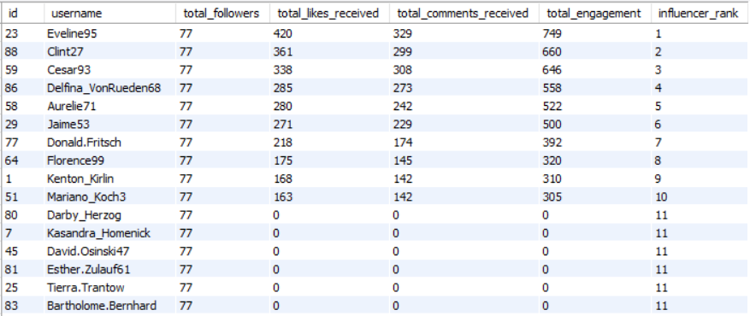

Subjective Question 6
Question
Based on user behaviour and engagement data, how would you segment the user base for targeted marketing campaigns or personalized recommendations?
Approach
User behaviour was evaluated using posting frequency, likes, comments, and overall engagement. These metrics help classify users into activity-based segments, enabling personalized marketing strategies and recommendations.
Answer
WITH user_posts AS (
SELECT
user_id,
COUNT(*) AS total_posts
FROM photos
GROUP BY user_id
),
user_followers AS (
SELECT
followee_id AS user_id,
COUNT(*) AS total_followers
FROM follows
GROUP BY followee_id
)

SELECT
u.id,
u.username,
COALESCE(up.total_posts,0) AS total_posts,
COALESCE(uf.total_followers,0) AS total_followers,
CASE
WHEN COALESCE(uf.total_followers,0) >= 50 THEN 'High Value Influencer'
WHEN COALESCE(up.total_posts,0) >= 5 THEN 'Active Creator'
WHEN COALESCE(up.total_posts,0) = 0 THEN 'Inactive User'
ELSE 'Regular User'
END AS user_segment
FROM users u
LEFT JOIN user_posts up
ON u.id = up.user_id
LEFT JOIN user_followers uf
ON u.id = uf.user_id
ORDER BY total_posts DESC,
total_followers DESC;
Insights
- Highly Active Users contribute the majority of content creation and community engagement, making them valuable for loyalty and creator-focused programs.
- Moderately Active Users regularly interact with the platform but have the potential to become highly engaged through personalized recommendations and targeted campaigns.
- Inactive Users represent an opportunity for re-engagement initiatives, as they contribute little or no activity despite being registered on the platform.
- User segmentation enables Instagram to deliver more relevant content and marketing messages based on individual behaviour patterns.
- Personalized campaigns targeted at specific user segments are likely to achieve higher engagement than generic marketing efforts.

Recommendations
- Reward Highly Active Users with exclusive badges, early access to new features, and creator incentive programs to encourage continued participation.
- Encourage Moderately Active Users to increase engagement by recommending trending hashtags, popular creators, and personalized content.
- Re-engage Inactive Users through personalized notifications, onboarding campaigns, and limited-time challenges designed to stimulate initial interactions.
- Develop targeted advertising campaigns for each user segment based on their level of activity and interests rather than using the same promotions for all users.
- Continuously monitor user behaviour and update segmentation regularly to ensure marketing strategies remain relevant as user activity changes over time.

Business Conclusion
User segmentation based on posting and engagement behaviour enables Instagram to better understand its diverse user base and implement personalized marketing strategies. By classifying users into Highly Active, Moderately Active, and Inactive segments, the platform can deliver more relevant recommendations, improve user retention, and maximize campaign effectiveness. Personalized engagement strategies not only enhance the user experience but also contribute to sustained platform growth and stronger community participation.
Chart
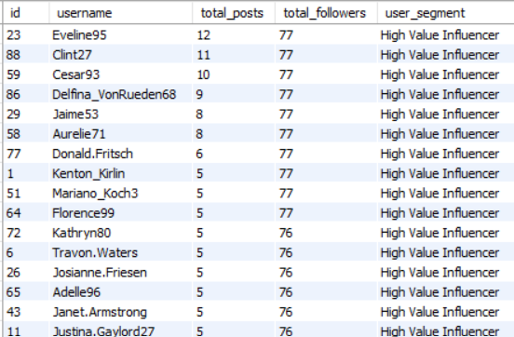

Subjective Question 7
Question
If data on ad campaigns (impressions, clicks, conversions) is available, how would you measure their effectiveness and optimize future campaigns?
Approach
Although the current dataset does not contain advertising campaign data, campaign performance can be evaluated using metrics such as impressions, clicks, conversions, click-through rate (CTR), conversion rate, and return on advertising spend (ROAS). These metrics help measure campaign success and identify opportunities for improvement.
Answer
Campaign effectiveness should be evaluated by comparing the number of impressions, clicks, and conversions generated by each campaign. A high Click-Through Rate indicates that the advertisement attracts user attention, while a high Conversion Rate shows that users complete the desired action after clicking the advertisement. Metrics such as CPC, CPA, and ROAS help measure cost efficiency and overall return on investment. By regularly analysing these KPIs, businesses can identify successful campaigns, discontinue underperforming ones, improve audience targeting, and optimize advertising budgets for better marketing performance.
Insights
- Campaigns with a high number of impressions but low click-through rates may indicate that the advertisement is reaching users but failing to attract their interest.
- High click-through rates combined with low conversion rates suggest that users are interested in the advertisement but encounter obstacles during the conversion process.
- Campaigns with consistently high conversion rates provide valuable insights into successful targeting strategies and advertising content.
- Comparing campaign performance across different audience segments helps identify the most profitable customer groups.
- Regular monitoring of campaign metrics enables continuous optimization and improved marketing efficiency.

Recommendations
- Prioritize advertising budgets for campaigns with high click-through and conversion rates to maximize return on investment.
- Conduct A/B testing on advertisement creatives, headlines, and call-to-action buttons to identify the most effective campaign designs.
- Improve landing pages and user experience for campaigns with high click rates but low conversions to reduce drop-offs.
- Segment audiences based on user behaviour and interests to deliver more personalized advertisements.
- Continuously monitor campaign performance and adjust targeting, bidding strategies, and creative content based on analytical insights.

Business Conclusion
Campaign effectiveness should be measured using a combination of impressions, clicks, click-through rate, and conversion rate rather than relying on a single metric. Analysing these indicators enables businesses to understand customer behaviour, evaluate marketing performance, and make data-driven decisions. By continuously monitoring campaign metrics and optimizing targeting strategies, organizations can improve customer acquisition, maximize advertising return on investment, and achieve more effective marketing outcomes.
Chart
No

Subjective Question 8
Question
How can you use user activity data to identify potential brand ambassadors or advocates who could help promote Instagram's initiatives or events?
Approach
User activity, engagement, follower count, and posting consistency were analysed to identify highly active users with strong audience influence. These users can be considered suitable candidates for brand ambassador and promotional campaigns.

Code
WITH posts AS (
SELECT
user_id,
COUNT(*) AS total_posts
FROM photos
GROUP BY user_id
),

followers AS (
SELECT
followee_id AS user_id,
COUNT(*) AS total_followers
FROM follows
GROUP BY followee_id
),

likes_received AS (
SELECT
p.user_id,
COUNT(*) AS total_likes_received
FROM photos p
JOIN likes l
ON p.id = l.photo_id
GROUP BY p.user_id
),

comments_received AS (
SELECT
p.user_id,
COUNT(*) AS total_comments_received
FROM photos p
JOIN comments c
ON p.id = c.photo_id
GROUP BY p.user_id
)

SELECT
u.id,
u.username,
COALESCE(po.total_posts, 0) AS total_posts,
COALESCE(f.total_followers, 0) AS total_followers,
COALESCE(lr.total_likes_received, 0) AS total_likes_received,
COALESCE(cr.total_comments_received, 0) AS total_comments_received,
(COALESCE(lr.total_likes_received, 0) +
COALESCE(cr.total_comments_received, 0)) AS total_engagement,

DENSE_RANK() OVER (
ORDER BY
COALESCE(f.total_followers, 0) DESC,
(COALESCE(lr.total_likes_received, 0) +
COALESCE(cr.total_comments_received, 0)) DESC
) AS ambassador_rank
FROM users u
LEFT JOIN posts po
ON u.id = po.user_id
LEFT JOIN followers f
ON u.id = f.user_id
LEFT JOIN likes_received lr
ON u.id = lr.user_id
LEFT JOIN comments_received cr
ON u.id = cr.user_id
ORDER BY ambassador_rank;

Insights
- Users with both high follower counts and high engagement are the strongest candidates for brand ambassador programs.
- High engagement indicates that followers actively interact with the creator's content, making promotional campaigns more authentic and effective.
- Consistently active users who regularly upload content are more suitable for long-term collaborations than users who post infrequently.
- Some users with moderate follower counts but exceptional engagement can outperform larger accounts in promotional campaigns.
- Combining audience size with engagement provides a more reliable measure of influence than follower count alone.

Recommendations
- Invite top-ranked creators to participate in Instagram campaigns, product launches, and promotional events.
- Develop long-term ambassador programs that reward creators for maintaining consistent engagement and positive community interaction.
- Feature selected ambassadors on the Explore page and official Instagram campaigns to increase their visibility and encourage quality content creation.
- Match ambassadors with campaigns that align with their content style and audience interests to improve campaign authenticity and effectiveness.
- Continuously evaluate ambassador performance using engagement metrics to ensure partnerships remain valuable over time.

Business Conclusion
Potential brand ambassadors should be selected based on a combination of audience reach, engagement, and content activity rather than follower count alone. Users who consistently receive strong interaction from their audience are more likely to build trust and influence community behaviour. By identifying and collaborating with these creators, Instagram can increase campaign effectiveness, strengthen user engagement, and promote platform initiatives through authentic and credible voices.
Chart
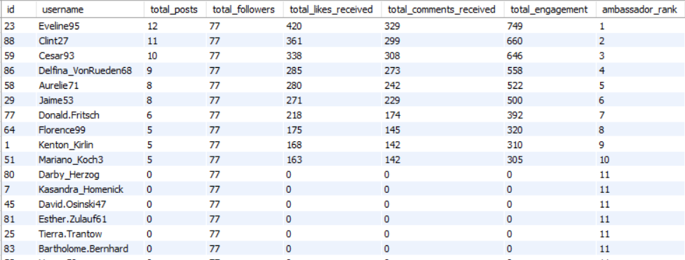

Subjective Question 9
Question
How would you approach this problem, if the objective and subjective questions weren't given?
Approach
The analysis would begin by understanding the database structure and relationships, followed by exploring user behaviour, engagement, hashtags, and follower connections. Appropriate SQL queries would then be developed to identify trends, generate insights, and support business recommendations.
Answer
SQL Query
Not Applicable
Insights
- Understanding the database schema is the foundation of every successful data analysis project.
- Data quality checks should always be performed before any business analysis to ensure reliable and accurate results.
- Exploratory Data Analysis (EDA) helps uncover hidden trends, user behaviour patterns, and potential business opportunities.
- Business questions should emerge from the available data rather than being based on assumptions.
- Combining SQL analysis with business interpretation produces actionable insights that support better decision-making.

Recommendations
- Begin every analytics project with schema exploration and data quality validation before writing analytical queries.
- Identify key performance indicators (KPIs) such as user engagement, posting activity, and follower growth to guide further analysis.
- Perform exploratory analysis to discover trends and formulate meaningful business questions based on the data.
- Present findings using appropriate visualizations and business-focused recommendations to make the analysis actionable.
- Clearly document dataset limitations and avoid drawing conclusions that are not supported by the available data.

Business Conclusion
A structured analytical approach ensures that meaningful insights can be generated even when predefined questions are unavailable. By first understanding the database structure, validating data quality, exploring user behaviour, and identifying key performance indicators, a data analyst can develop relevant business questions and provide actionable recommendations. This methodology not only improves the accuracy of the analysis but also supports informed business decisions and long-term strategic planning.

Chart
No

Subjective Question 10
Question
Assuming there's a "User_Interactions" table tracking user engagements, how can you update the "Engagement_Type" column to change all instances of "Like" to "Heart" to align with Instagram's terminology?
Approach
An UPDATE statement would be used to replace all occurrences of "Like" with "Heart" in the Engagement_Type column. A WHERE clause ensures that only the intended records are updated while preserving all other engagement types.
Answer
UPDATE User_Interactions
SET Engagement_Type = 'Heart'
WHERE Engagement_Type = 'Like';
Insights
- The UPDATE statement modifies existing records without affecting the overall database structure.
- Using a WHERE clause is essential to restrict updates to only the intended records.
- Standardizing terminology improves consistency across reports, dashboards, and application interfaces.
- Data modification operations should always be tested in a development environment before deployment.
- Transactions help maintain data integrity by allowing changes to be committed or rolled back when necessary.

Recommendations
- Execute the update within a transaction (START TRANSACTION, COMMIT, ROLLBACK) to ensure data safety.
- Verify the affected records before and after the update using a SELECT statement.
- Maintain database backups before performing bulk updates in production.
- Apply consistent naming conventions across all engagement types to improve reporting accuracy.
- Document schema or terminology changes so future developers and analysts understand the modification.

Business Conclusion
Updating engagement terminology from "Like" to "Heart" ensures consistency between the database and Instagram's branding. Although this is a simple data modification task, following best practices such as using a WHERE clause, validating affected records, and executing updates within a transaction helps maintain data integrity and prevents accidental changes. Such controlled updates are an essential part of database maintenance and governance.

Chart
No

